Co-Chair  Charleta B. Tavares  Assistant Minority Leader  15th Senate District | 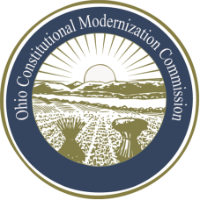 | Co-Chair  William G. Batchelder, Speaker  69th House District
Ohio Constitutional Modernization Commission

MEMORANDUM

To: Speaker Batchelder & Senator Tavares, Co-Chairs
From: Jeff Jacobson, Vice Chair
Date: 02/24/2014
Re: Bill of Rights and Voting Committee Report for February 13, 2014

Members Present: Vice Chair Jacobson, Representative Amstutz, Karla Bell, Douglas Cole, Representative Clyde, Judge Fischer, Senator Peterson, and Senator Skindell.

Topics Discussed: Dr. John Dinan, Professor of Political Science at Wake Forest University, addressed the committee and took questions on recent trends in amendments to state bills of rights.
Witnesses: Dr. John Dinan, Professor of Political Science at Wake Forest University

Other Items of Discussion: Following his presentation, the Committee considered two proposed public notice policy drafts and unanimously adopted the proposal drafted by Dean Steinglass

Votes Taken: n/a

Next Meeting: March 13, 2014

